**Institute of Engineering & Management**

**Department of Computer Science & Engineering**

**Object Oriented Programming (IT) Lab for 3rd year 5th semester 2018**

**Code: CS594D**

**Date:** 9/10/2018

**WEEK-10**

**Assignment-1**

**Problem Statement:** Write a java program to demonstrate “throw”

**Source code:**

public class usethrow  
{  
 public **static** void main(String []args)  
 {  
 int i=5,j=10,k=0;  
 try{  
 k=i+j;  
 if(k>10) {  
 throw new Exception();  
 }  
 }  
 catch(Exception e){  
 System.***out***.println("Cannot take k>10");  
 }  
 }  
}

**Screen-Shot:**

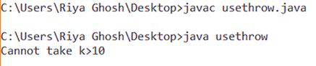

**Assignment-2**

**Problem Statement:** Write a java program to explain “throws”

**Source code:**

import java.io.IOException;

class usethrows

{

void m()throws IOException

{

throw new IOException("device error");

}

void n()throws IOException

{

m();

}

void p()

{

try{

n();

}

catch(Exception e){

System.out.println("exception handled");

}

}

public static void main(String args[])

{

usethrows obj=new usethrows();

obj.p();

System.out.println("normal flow...");

}

}

**Screen-Shot:**

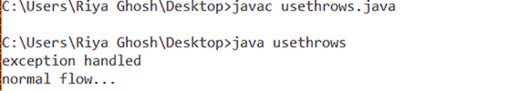

**Assignment-3**

**Problem Statement:** Consider a class that represents an account in a bank. Let the minimum balance for the account be Rs. 1000. Write a java program that throws an exception when a withdrawal result in the balance decrease to the value less than Rs. 1000.

**Source code:**

class LowBalance extends Exception

{

String s;

LowBalance (double d)

{

if(d<1000.0)

{

s="Low Balance!!!";

}

}

public String toString()

{

return s;

}

}

class Balance

{

double d;

Balance()

{

d=1000.0;

}

Balance(double x)

{

d=x;

}

void withdrawl(double y) throws LowBalance

{

if((d-y)>=1000.0)

{

d=d-y;

System.out.println("Updated balance="+d);

}

else{

throw new LowBalance(d-y);

}

}

}

class exce

{

public static void main(String[]ar)

{

Balance b=new Balance(5000.0);

try{

b.withdrawl(4500.0);

}

catch(LowBalance E){

System.out.println(E);

}

}

}

**Screen-Shot:**

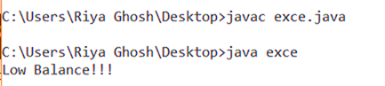

**Assignment-4**

**Problem Statement:** Write a java program to find the factorial of any number and it can throw an exception ‘NegativeNumber’ if your entered number is a negative value.

**Source code:**

class Neg extends Exception //user defined exception

{

String s;

Neg (){

s="NEGATIVE NUMBER!!!";

}

public String toString()

{

return s;

}

}

class fac

{

int d;

fac(){

d=0;

}

fac(int x){

d=x;

}

void factorial() throws Neg

{

if(d<0)

{

throw new Neg();

}

else

{

int x=1;

for(int i=2;i<=d;i++)

x=x*i;

System.out.println(x);

}

}

}

class factorialexce

{

public static void main(String[]ar)

{

fac b=new fac(-5); //we are trying to find factorial of -5

try

{

b.factorial();

}

catch(Neg E)

{

System.out.println(E);

}

}

}

**Screen-Shot:**

